SIFF 2026
Singapore International Food Forum 2026
Curcumin Cellular Delivery Based on Assembly of Clover Shaped Trityl Polyethylene Glycols with Ovalbumin
Zhe Zheng ª, Songbai Liu ^{a*}
ª Department of Food Science and Nutrition, Zhejiang University, 866 Yuhangtang Road, Hangzhou 310058, China
Abstract
Novel curcumin (Cur) cellular delivery system based on assembly of clover shaped trityl polyethylene glycol (TrPEG) with heat denatured ovalbumin (OVA) through hydrophobic interactions was developed in this study. TrPEGs of different degree polymerization (n=3, 6, 9) were prepared by the coupling of trityl chloride and PEGs under the optimized condition, and the structures were verified by NMR and MS measurements. The excellent amphiphilic and biocompatible TrPEG-9 demonstrated marvelous selective binding capability with the denatured OVA and stabilization of the assembled particles through the clover shaped head. Introduction of TrPEG-9 with OVA significantly enhanced encapsulation efficiency (83%) of Cur and afforded uniform compact nanoparticles (63 nm). Evaluation by Saccharomyces cerevisiae model revealed effectively promoted Cur cellular delivery and significantly reactive oxygen species (ROS) reduction capacity of EG-OVA-Cur, and clathrin-mediated endocytosis and macropinocytosis cellular uptake followed by intracellular vacuolar trafficking. This assembled system has great potential for cellular delivery of nutraceutical and biomedical bioactives.
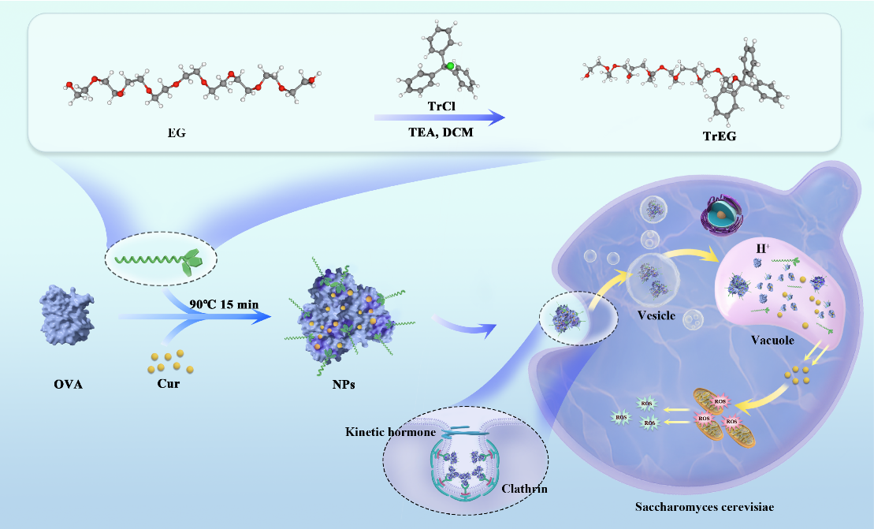
References
[1] Wang, P. F., & Liu, S. B. (2020). Development of a gemini interfacial antioxidant for oil in water emulsion with gallic acid and dodecyl gemini chains. Journal of agricultural and food chemistry, 68(37), 9953-9960.
[2] Feng, J., Wu, S. S., Wang, H., & Liu, S. B. (2017). Gliadin nanoparticles stabilized by a combination of thermally denatured ovalbumin with gemini dodecyl O-glucoside: The modulating effect of cosurfactant. Colloids and Surfaces a-Physicochemical and Engineering Aspects, 516, 94-105.

