Green Biomanufacturing of Microalgae Based on Hydrogel Platforms
Jiajing Zhou ^{1,*}
¹ College of Biomass Science and Engineering, Sichuan University, Chengdu 610065, China
*Email: jjzhou@scu.edu.cn

Microalgae are natural cellular factories capable of producing high-value products, including proteins, carbohydrates, and lipids. Conventional cultivation in open ponds and photobioreactors suffer from low photosynthetic productivity and complex harvesting processes, which restrict the large-scale application of microalgae. In this study, microalgae were immobilized in a three-dimensional hydrogel matrix with efficient gas exchange and nutrient transport, establishing a hydrogel-based cultivation platform for sustainable microalgae biomanufacturing^{[1,2]}. This approach significantly reduces land and water requirements, improves space-use efficiency, and enables high-productivity cultivation with simplified biomass harvesting. Moreover, the hydrogel matrix can protect microalgae from environmental stresses, expanding their applications in biomedicine and ecological remediation^{[3–5]} while promoting the development of high-value function materials derived from sustainable microalgae.
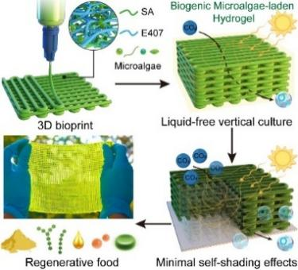
Fig. 1 Schematic of microalgae hydrogel printing and cultivation
Keywords: hydrogel; microalgae; biomanufacturing; green and low-carbon; functional materials
References
[1] Liu, H.; Yu, S.; Liu B.; Xiang, S.; Jiang, M.; Yang, F.; Tan, W.; Zhou, J.; Xiao, M.; Li, X.; Richardson, J. J.; Lin, W.; Zhou, J. Adv. Mater. 2024, 36, 2401172.
[2] Liu, H.; Mei, H.; Jiang, H.; Jiang, L.; Lin, K.; Jiang, M.; Ding, N.; Li, X.; Gao, Z.; Liu, B.; Lin, W.; Li, J.; Zhou, J. Small 2025, 21, 2407105.
[3] Li, X.; Liu, H.; Lin, Z.; Richardson, J. J.; Xie, W.; Chen, F.; Lin, W.; Caruso, F.; Zhou, J.; Liu, B. Adv. Sci. 2024, 11, 2198-3844.
[4] Jiang, M; Zheng, J.; Tang, Y., Liu, H.; Yao Y.; Zhou, J.; Lin, W.; Ma, Y.; Liu, J.; Zhou, J. Nat. Commun. 2025, 16, 3160.
[5] Liu, X.; Ding, N.; Zeng, Y.; Lai, J.; Liu, H.; Jiang, M.; Tan, W.; Mei, H.; Li, X.; Liu, L.; Chen, Y.; Yao, Y.; Li, Z.; Zhou, J. Adv. Funct. Mater. 2026, 36, e15705.
Briefing of the Reporter:
Dr. Jiajing Zhou is a professor at Sichuan University. He currently serves as deputy director of Key Laboratory of Leather Chemistry and Engineering of Ministry of Education, assistant dean of College of Biomass Science and Engineering, and associate editor of Leather Science and Engineering and Biomass Utilization. He received his B.Eng. from Sichuan University and Ph.D. from Nanyang Technological University, followed by postdoctoral research at University of Melbourne and University of California, San Diego. His research team focuses on the construction of functional assemblies from biomass materials across nano- to macroscale dimensions and the development of carbon-neutral technologies based on renewable biomass resources. To date, he has published over 100 papers in high-impact journals including Nat. Rev. Chem., Nat. Sustain., Nat. Commun., J. Am. Chem. Soc., Angew. Chem. Int. Ed., and Adv. Mater., with total citations exceeding 8,500.


